Analysing top selling product

* Top selling product across all the stores – GM HONEY NUTS CHEERIOS

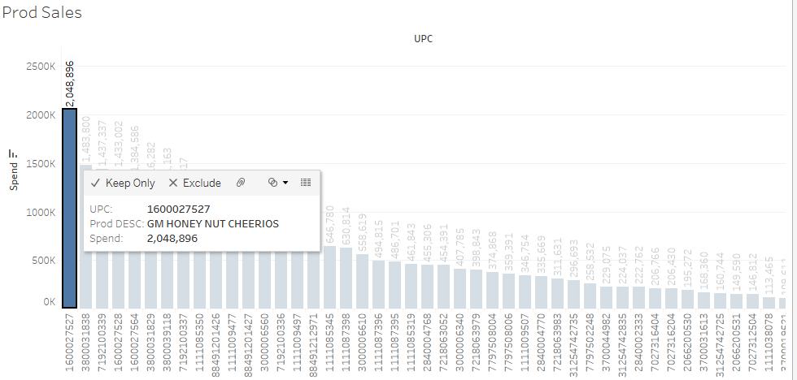

* Comparing the promotional modes in top 3 stores against bottom 3 stores

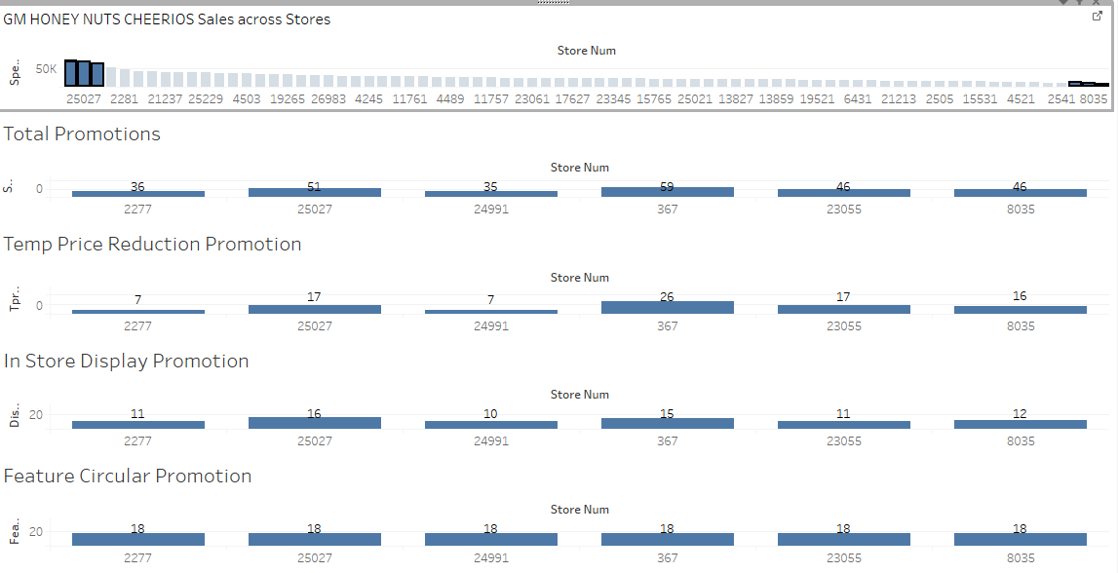

We see that there is a variation in TPR and Display promotion used among the stores, but the Feature promotion is mostly 18 times used over the period of 3 yrs in each store.

So we tried to look which promotion is significantly contributing to the sales, so that focus on that mode of promotion will be beneficiary.

Bottom 3 store

Store Id: 8035

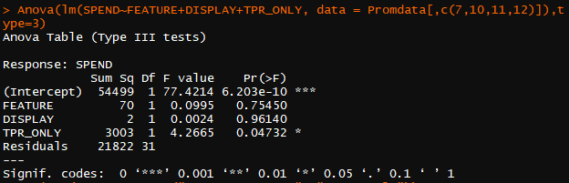

Store id: 23055

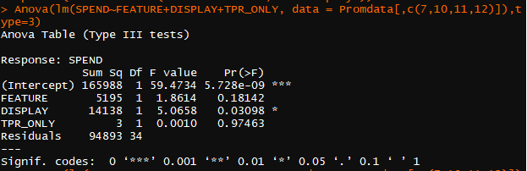

Store Id: 367

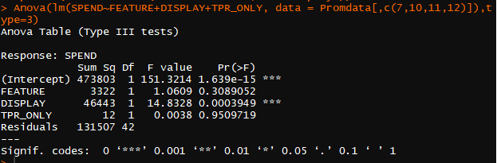

Top 2 Store

Store id: 2277

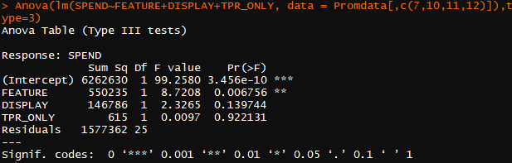

Store id: 25027

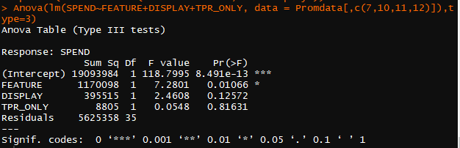

Here we found that,

Top 1 Store has given total of 36 promotions (7 – TPR, 11 – Display, 18- Feature),

Bottom 1 Store has given 46 promotions (16- TPR, 12- Display, 18 – Feature).

From the above ANOVA results for the Sales and 3 modes of promotion, we found that the bottom store has either Temporary Price Reduction TPR or Display as most significant while the top has Feature promotion. So we conclude the business to implement TPR promotion or Display based in bottom stores instead of others, while in top stores Feature promotion is the most suitable.

Clustering stores based on their PARKING, AREA_SIZE_STORE, AVG_WEEKLY_BASKETS, AVG_WEEKLY_VISITS. We found that there are 3 optimal clusters (based on within cluster sum of squared error – Elbow method) that can be formed based on these features using KMeans.

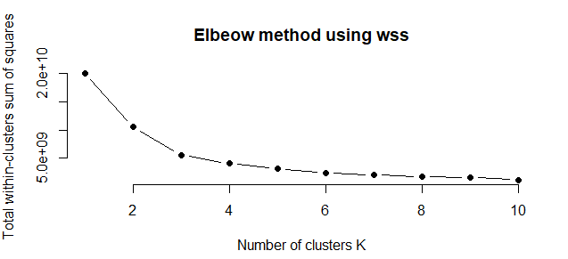

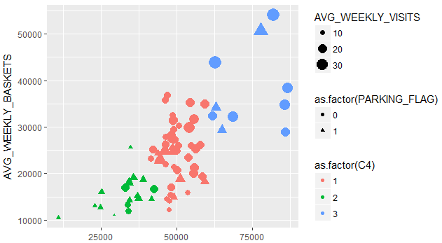

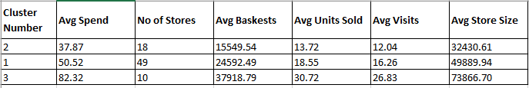

Cluster 3

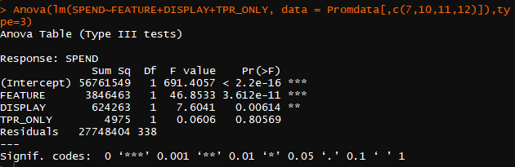Cluster 2

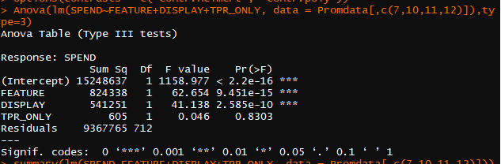

Cluster 1

